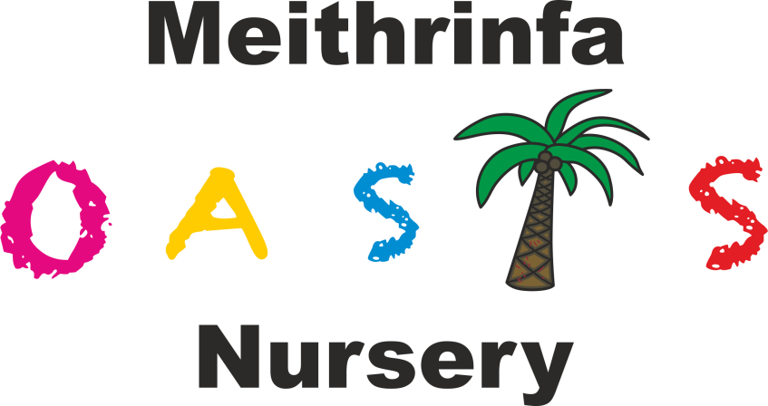

Promoting Positive Behaviour Policy

At Oasis Nursery we believe that children flourish best when they feel safe and secure and have their needs met by supportive practitioners who act as good role models, show them respect and value their individual personalities. Children are supported through co-regulation, where adults and children work together towards a common purpose, including finding ways to resolve upsets from stress in any domain and return to balance leading onto a path to self-regulation. The nursery encourages and praises positive, caring and polite behaviour at all times and provides an environment where children learn to respect themselves, other people and their surroundings.

We implement the early years curriculum supporting children to develop their personal, social and emotional development. This involves helping children to understand their own and others’ feelings, and beginto regulate their behaviour. We support children to do this through working together with parents, having consistent approaches and age/stage appropriate boundaries. We help build confidence and self-esteem by valuing all children and giving lots of praise and encouragement.

To support positive behaviour in our setting, we aim to:
- Recognise the individuality of all our children
- Provide a warm, responsive relationship where children feel respected, comforted and supported in times of stress, and confident that they are cared for at all times
- Understand that certain behaviours are a normal part of some young children’s development e.g. biting
- Encourage self-regulation consideration for each other, our surroundings and property
- Encourage children to participate in a wide range of group activities to enable them to develop their social skills
- Ensure that all staff act as positive role models for children
- Encourage parents, carers and other visitors to be positive role models. Work in partnership with parents/carers by communicating openly
- Praise children and acknowledge their positive actions and attitudes, therefore ensuring that children see that we value and respect them
- Encourage all staff working with children to accept their responsibility for implementing the goals in this policy and to be consistent
- Promote non-violence and encourage children to deal with conflict peacefully
- Staff are kept with the same groups as much as possible enabling staff to build a strong and positive relationship with children and their families
- Provide activities and stories to help children learn about accepted behaviours, including opportunities for children to contribute to decisions about accepted behaviour where age/stage appropriate
- Support and develop children’s understanding of different feelings and emotions, self-regulation and empathy as appropriate to stage of development. This includes using strategies, naming and talking about feelings and ways to manage them
- Have a named person who has overall responsibility for promoting positive behaviour and behaviour support.

The named person for promoting and supporting behaviour is Liza Morris. It is their role to:
- Advise and support other staff on any behaviour concerns
- Liaise with the setting’s designated person for additional learning needs where a child requires further support or there are concerns about the impact of the behaviour on a child’s education and care
- Keep up to date with legislation and research relating to promoting positive behaviour, along with each staff member
- Support changes to policies and procedures in the nursery
- Access relevant sources of expertise where required and act as a central information source for all involved
- Attend necessary training as and when it is available.

Our nursery rules are concerned with safety and care and respect for each other. We keep the rules to a minimum and ensure that these are age and stage appropriate. We regularly involve children in the process of setting rules to encourage cooperation and participation and ensure children gain understanding of the expectations of behaviour relevant to them as a unique child.

Children who are displaying distressed or challenging behaviour, for example, by physically abusing another child or adult e.g. biting, or through verbal bullying, are helped to talk through their feelings and actions through co-regulation, before thinking about the situation and apologising where appropriate. We make sure that the child who has been upset is comforted. We always acknowledge when a child is feeling angry or upset and that it is the behaviour that is not acceptable, not the child or their feelings.

Our promoting positive behaviour procedure is:
- We support all children to develop positive behaviour, and we make every effort to provide for their individual needs
- We never use or threaten to use physical punishment or corporal punishment, such as smacking or shaking, or use or threaten any punishment that could adversely affect a child’s well-being
- We only use physcial intervention (where practitioners may use reasonable force to prevent children from injuring themselves, others or damaging property) for the purpose of averting immediate danger or personal injury to any person (including the child) or to manage a child’s behaviour if absolutely necessary. We keep a record of any occasions where physical intervention is used and inform parents on the same day, or as reasonably practicable
- We recognise that there may be occasions where a child is displaying challenging or distressed behaviour and may need individual techniques to calm them to prevent a child from injuring themselves or others. This will be done by providing a supervised quiet place where a staff member can talk with the child to understand the cause of te behaviour. We will complete an incident form following the incident and talk with parent/carers to find the best way forward
- We do not single out children or humiliate them in any way. Where children are displaying challenging behaviour they will, wherever possible, be distracted and re-directed to alternative activities. Discussions with children will take place as to why their behaviour was not acceptable, respecting their level of understanding and maturity
- Staff do not shout (unless in the instance to keep children safe from immediate danger). Staff may firmly address any challenging behaviour and reminded to use kind words and kind hands.
- In cases of challenging behaviour, we always make it clear to the child or children in question, that it is the behaviour and not the child that is unwelcome
- We decide on particular strategies to support different types of behaviour depending on the child’s age, level of development and the circumstances surrounding the behaviour. This may involve asking the child to talk and think about what he/she has done. All staff support churt their peers. We beleive this builds empathy skills and a good understanding of why saying sorry is appropriate
- We help staff to reflect on their own responses towards behaviours that challenge to ensure that their reactions are appropriate
- We inform parents if their child’s behaviour is unkind to others or if their child has been upset. In all cases we deal with behaviour that challenges in nursery at the time. We may ask parents to meet with staff to discuss their child's behaviour, so that if there are any difficulties we can work together to ensure consistency between their home and the nursery. We use the quiet chair/thinking chair, if parents agree, to help children come to an understanding of their behaviour and to understand what caused it. In some cases we may request additional advice and support from other professionals, such as an educational psychologist
- We support children in developing non-aggressive strategies to enable them to express their feelings and emotions
- We keep confidential records on any behaviour that challenges that has taken place. We inform parents and ask them to read and sign any incidents concerning their child
- Through partnership with parents and formal observations, we make every effort to identify any behavioural concerns and the causes of that behaviour. From these observations and discussions, we will implement an individual behaviour support plan where a child’s behaviour involves aggressive actions towards other children and staff, for example hitting, kicking etc. The manager will complete risk assessments identifying any potential triggers or warning signs ensuring the safety of other children and staff at all times.

We recognise that children need their own time and space and that it is not always appropriate to expect a child to share. We believe it is important to acknowledge each child’s feelings and to help them understand how others might be feeling.

At our nursery, staff follow the procedure below to enable them to deal with behaviour that challenges:
- Staff are encouraged to ensure that all children feel safe, happy and secure
- Staff are encouraged to recognise that active physical aggression in the early years is part of the child’s development and that it should be channelled in a positive way
- Children are helped to understand that using aggression to get things is inappropriate and they will be encouraged to resolve problems in other ways
- Staff will initiate games and activities with children when they feel play has become overly boisterous or aggressive, both indoors and outdoors
- We will ensure that this policy is available for staff and parents and it will be shared at least once a year to parents and staff
- Staff and parents are also welcomed to review and comment on the policy and procedure
- If any parent has a concern about their child, a member of staff will be available to discuss those concerns. Working together can ensure our children feel confident and secure in their environment, both at home and in the nursery
- All concerns will be treated in the strictest confidence.

Anti-bullying
We encourage children to recognise that bullying, fighting, hurting and discriminatory comments are not acceptable behaviour. We want children to recognise that certain actions are right and that others are wrong.

Bullying takes many forms. It can be physical, verbal or emotional, but it is always a repeated behaviour that makes other people feel uncomfortable or threatened. We acknowledge that any form of bullying is unacceptable and will be dealt with immediately while recognising that physical aggression is part of children’s development in their early years. Staff will intervene when they think a child is being bullied, however mild or harmless it may seem, and sensitively discuss any instance of bullying with the parents of all involved to look for a consistent resolution to the behaviour.

By promoting positive behaviour, valuing co-operation and a caring attitude, we hope to ensure that children will develop a positive sense of self, have confidence in their own abilities, make good friendships, co-operate and resolve conflicts peaceably. These will provide them with a secure platform for school and later life.

Additional information to support this policy specific to 5-12 year olds:

At Oasis Nursery and within our LighthouseClub (After School and Holiday Club) we will implement the above policy for all our children who attend the setting. This will be adapted for older children by aiming to:
- Involve them in setting their own rules and regulations so they have ownership
- Work with schools and other settings to ensure that strategies to promote positive behaviour are consistent
- Ensure that activities and equipment is age appropriate to ensure that children are adequately challenged and therefore do not become bored, which could trigger challenging behaviour
- Work in partnership with parents to ensure that children’s interests and individual needs are met
- Seek further support from external agencies where required if children continued to display difficult or challenging behaviour and exisiting strategies were not working.

